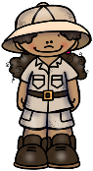
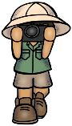Explorer Jr. Club (1)
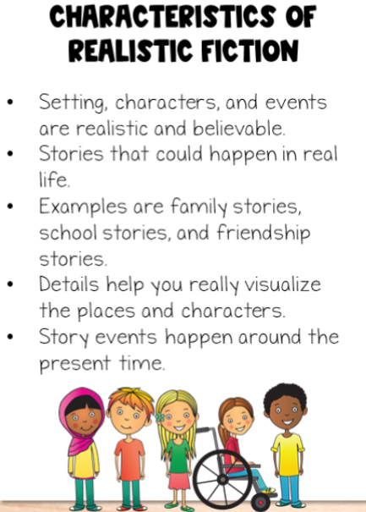 | GENRE: REALISTIC FICTION | GENRE: REALISTIC FICTION
 | Title:  Author: | Title:  Author:
 | GENRE: REALISTIC FICTION
Title:

Author:

Read 3 Realistic Fiction books. Write the title and author of each book very neatly in the boxes.
Student Name: __________________________________________ Teacher Name:__________________________
Yes, I verify that my child has read the above books:
Parent Signature: ___________________________________________________
Explorer Jr. Club (2)
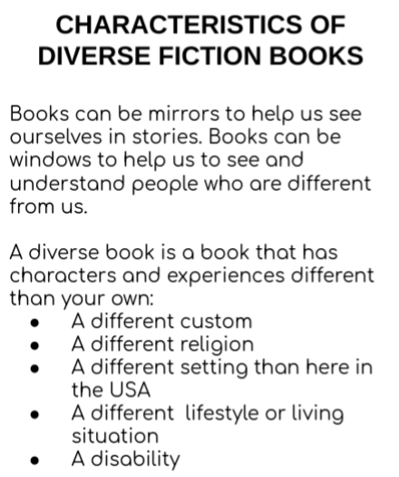 | GENRE: DIVERSE FICTION BOOK | GENRE: DIVERSE FICTION BOOK
 | Title:  Author: | Title:  Author:
 | GENRE: DIVERSE FICTION BOOK
Title:

Author:
Read 3 Diverse Fiction books. Write the title and author of each book very neatly in the boxes.
Student Name: __________________________________________________ Teacher Name:__________________________
Yes, I verify that my child has read the above books:
Parent Signature: ___________________________________________________

Explorer Jr. Club (3)
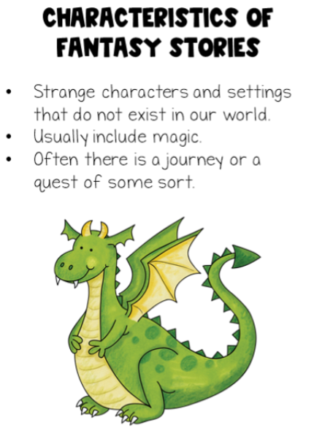 | GENRE: FANTASY FICTION | GENRE: FANTASY FICTION
 | Title:  Author: | Title:  Author:
 | GENRE: FANTASY FICTION
Title:

Author:

Read 3 FANTASY Fiction books. Write the title and author of each book very neatly in the boxes.
Student Name: __________________________________________ Teacher Name:__________________________
Yes, I verify that my child has read the above books:
Parent Signature: ___________________________________________________

Explorer Jr. Club (4)
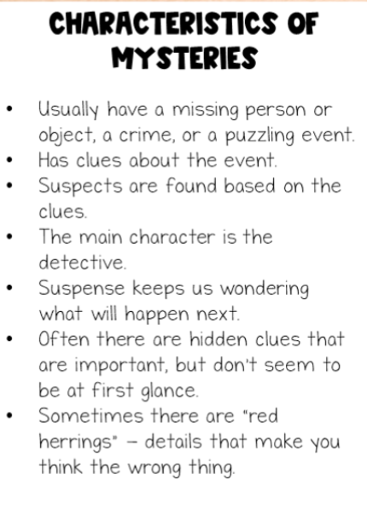 | GENRE: MYSTERY FICTION | GENRE: MYSTERY FICTION
 | Title:  Author: | Title:  Author:
 | GENRE: MYSTERY FICTION
Title:

Author:
Read 3 Mystery Fiction books. Write the title and author of each book very neatly in the boxes.
Student Name: __________________________________________ Teacher Name:__________________________
Yes, I verify that my child has read the above books:
Parent Signature: ___________________________________________________
Explorer Jr. Club (5)
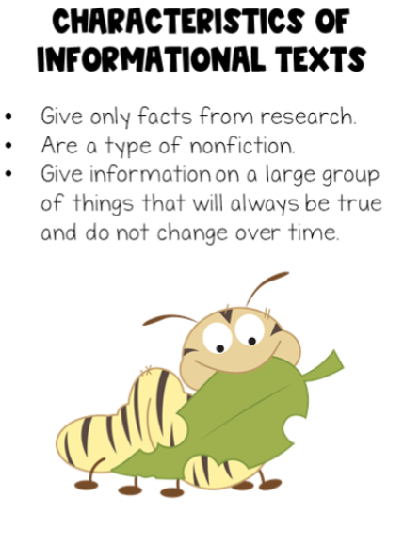 | GENRE: INFORMATIONAL BOOK | GENRE: INFORMATIONAL BOOK
 | Title:  Author: | Title:  Author:
 | GENRE: INFORMATIONAL BOOK
Title:

Author:

Read 3 Realistic Informational books. Write the title and author of each book very neatly in the boxes.
Student Name: __________________________________________ Teacher Name:__________________________
Yes, I verify that my child has read the above books:
Parent Signature: ___________________________________________________

Explorer Jr. Club (6)
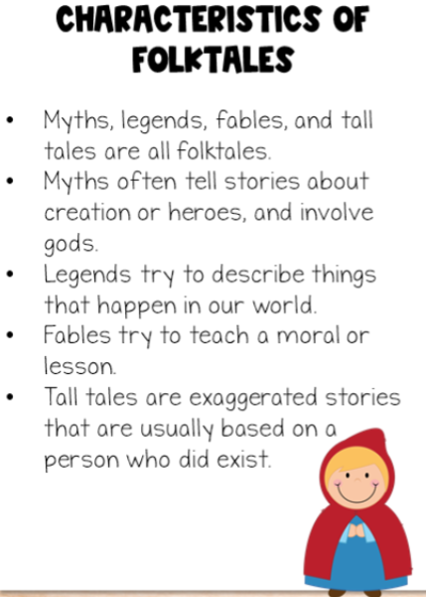 | GENRE: FOLKTALE | GENRE: FOLKTALE
 | Title:  Author: | Title:  Author:
 | GENRE: FOLKTALE
Title:

Author:

Read 3 Folktale books. Write the title and author of each book very neatly in the boxes.
Student Name: __________________________________________ Teacher Name:__________________________
Yes, I verify that my child has read the above books:
Parent Signature: ___________________________________________________
Explorer Jr. Club (7)
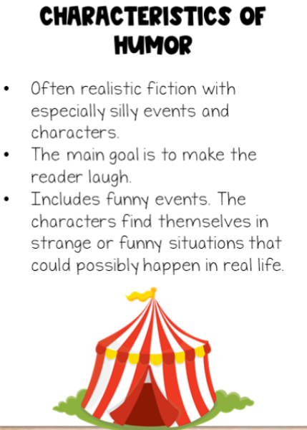 | GENRE: HUMOR FICTION | GENRE: HUMOR FICTION
 | Title:  Author: | Title:  Author:
 | GENRE: HUMOR FICTION
Title:

Author:

Read 3 HUMOR Fiction books. Write the title and author of each book very neatly in the boxes.
Student Name: __________________________________________ Teacher Name:__________________________
Yes, I verify that my child has read the above books:
Parent Signature: ___________________________________________________
Explorer Jr. Club (8)
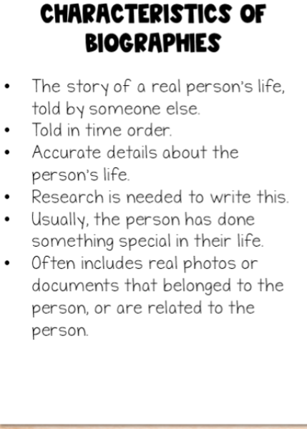 | GENRE: BIOGRAPHY | GENRE: BIOGRAPHY
 | Title:  Author: | Title:  Author:
 | GENRE: BIOGRAPHY
Title:

Author:

Read 3 Biography books. Write the title and author of each book very neatly in the boxes.
Student Name: __________________________________________ Teacher Name:__________________________
Yes, I verify that my child has read the above books:
Parent Signature: ___________________________________________________
Explorer Jr. Club (9)
FREE CHOICE:  Read 3 books. The only rule is that each book must be a different genre (type of book). Your choices:  - Biography  - Diverse Fiction Book  - Fantasy Book  - Folktale  - Humor Book  - Information book  - Mystery Book  - Realistic Fiction book  See Explorer Jr. Club organizers 1-8 to learn the characteristics of each of these genres.  Don’t forget: Write the genre name in each book. | GENRE: | GENRE:
 | Title:  Author: | Title:  Author:
 | GENRE:
Title:

Author:

Read 3 books. Write the genre, title and author of each book very neatly in the boxes.
Student Name: __________________________________________ Teacher Name:__________________________
Yes, I verify that my child has read the above books:
Parent Signature: ___________________________________________________

