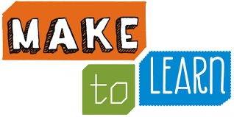

April Creative Reader Challenge

To help students grow up with a maker mindset and sustain their natural curiosity for discovery, learning, and creating, the Lowe Library is challenging students to read and learn about a topic of interest and then create their own “Do It Yourself” project during the month of April. We encourage students to explore everything from building with cardboard to making a working circuit through student-driven and developmentally appropriate projects.
Students interested in this month’s Creative Reader Challenge should read a text about a topic of interest, create a project using what they learned, and bring it to the library to display (or a picture of it if it is too large). The library has several books in its Arts section including cooking, drawing, sports and crafts. There is also plenty of “maker space” and “DIY” sites available on the internet as well as books available at the public library and local bookstores.
All participants will be entered into a drawing to win one of three DIY kits generously donated by Michaels at Westport Road or a free parent/student pass to the WonderLab Museum of Science, Health and Technology in Bloomington, Indiana.
If your child is up to this month’s challenge, please fill out the form below and turn it in with your child’s completed project.
-----------------------------------------------------------------------------------------------------------------------------------------
Student Name: __________________________________ Teacher: ______________________

Project Title: __________________________________________________

Title/author of book or website used to learn about the topic of interest:

Favorite part of the project:

___________________________________________________________________________________

