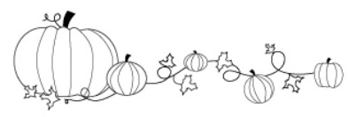
Lowe Library
Book Character Decorating Contest

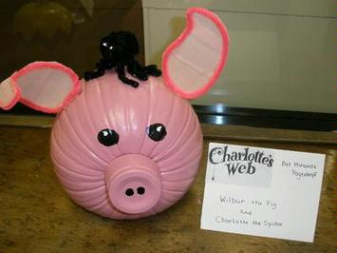
This year the library is getting into the fall spirit by having a pumpkin decorating contest of your favorite book character. It’s easy and fun for the whole family. Pumpkins may be dropped off at the library any day up to Thursday, October 28th. Students may retrieve their pumpkin on October 30th so it can be displayed at home during fall celebrations. Each student who participates in the contest, and follows the contest rules, will be entered into two drawings:
- A gift certificate for a free pair of tickets to Tinseltown Movie Theater.
- A board game and a gift certificate for a free pizza.

CONTEST RULES:
- Absolutely no carved pumpkins. Carved pumpkins rot, attract bugs, and smell. Carved pumpkins will be sent back home. To decorate you can use paper, glue, paint, markers, pipe cleaners, fabric, or other craft items on the pumpkin. Let your creativity soar! There are plenty of ideas on the internet. Styrofoam pumpkins and plastic pumpkins work well with this type of project.
- Pumpkins must represent a book character. On the entry form below please state the character, title and author of the book. Please affix this form to the pumpkin with string or tape.
- This is a home project and pumpkins should be done mostly by the students but parents or other family members may assist.
- Families who have more than one student at Lowe may like to submit one decorated pumpkin for the whole family or multiple pumpkins representing various characters in the same book.

Book Character
Pumpkin Decorating Contest

Student Name: _________________________________ Teacher Name: ________________________
Title: _________________________________________________________________________________
Author: ____________________________ Book Character: __________________________________

