Students can count the first 10 books they read this summer towards both their Summer Reading logs and Book Wars forms! Students must log their books on Beanstack to get their Summer Reading prizes and turn this form in to the library to be counted in the Book Wars. Students may turn in additional forms, but they must include different titles. Only Book War forms will be counted for your school's points in the Book Wars.
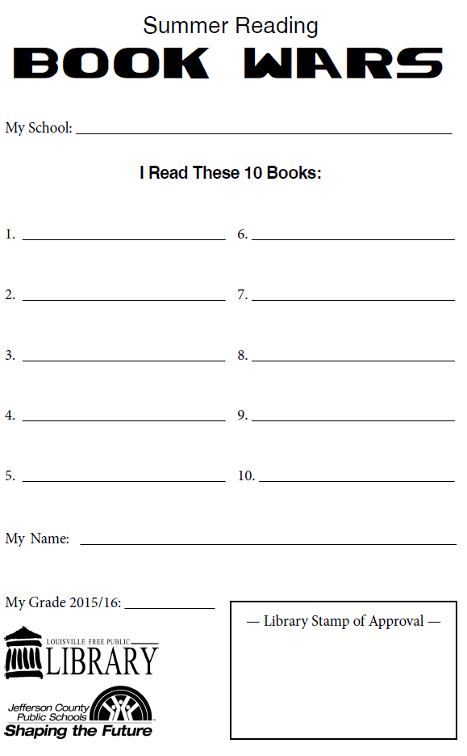
My Grade 2017/2018
June 1st – August 12th

Students can count the first 10 books they read this Summer towards their Summer Reading Books logs and Book Wars forms! Students must log their books on Beanstack to get their Summer Reading prizes and turn this form in to the library to be counted in the Book Wars. All additional books students read for the Book Wars must be recorded on the Book War form. Only Book War forms will be counted for your school's points in the Book Wars.
My Grade 2017/2018

June 1st – August 12th

